**PHP and MySQL**

# **Session 4 Practical Sessions**

This week you will create a simple shopping application that sells widgets. The application will request the number of widgets the client wishes to order and then on a separate page their preferred colour. Finally, a third page will confirm the qty and colour selected.

The Web Application design is below – familiarise yourself with the design before looking at the scripts on the following page.



























Create the **three** files below and run the application by loading shop.html into your browser.

Does the confirmation display both the qty and colour ?

## The file below should be saved as **shop.html**



The file below should be saved as **selectcolour.php**



The file below should be saved as **confirmation.php**



**Exercise 1**

Your first task this week is to amend the code so that the qty of widgets is displayed within confirmation.php . Try each of the following methods

* Hidden fields
* Cookies
* Session variables

Use the example applications on the back of this practical as a guide.

Which of the three methods was easiest to implement ?

I did NOT use these methods for my work, I implemented my own method which makes it so that selqty is properly passed and displayed. I’ve also made the end message more readable, for the user to know exactly the information being displayed.

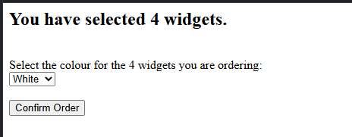

As an end result, it now displays the amount of widget when the order is confirmed.



## **Exercise 2**

You may have noticed that no prices have been included within the application. Our customer was not happy about this, stating that “I’m not a running a charity !“ or words to that effect.

Your next task is to include a price for the widgets and for a total price ( qty * price ) to be displayed within confirmation.php. The initial price should be displayed within shop.html. One solution would be to include the following line

<input type=”text” name=”txtprice” size=”10” value=”15.75” readonly />

after the select control that displays the qty.

Use any of the three methods to access the price within confirmation.php so that a total cost can be calculated and displayed.

I’ve amended the code so that an example price of $10 is set for each of the widgets inside of selectcolour.php. The total price of this is calculated by multiplying the amount inside selqty by the price per widget, which is then continued into confirmation.php.

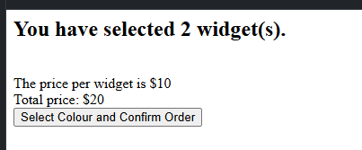

As an end result, it shows how many widgets have been selected, the price per widget, and the total price.

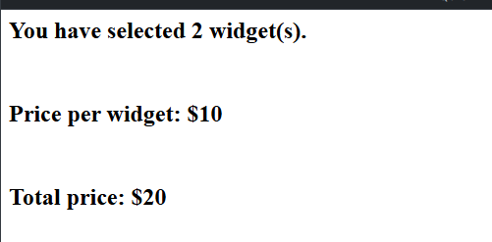

## **Exercise 3**

Our customer has decided to sell different sizes of widgets. They now come in the following sizes.

* Small (£15.75)
* Medium (£16.75)
* Large (£17.75)
* Extra large (£18.75)

Create a new page called size.php for size selection, it should be displayed after the qty is selected but before the colour. Remember to change the form’s action attributes within shop.html to ensure the pages are called in the correct order. The price now depends upon the size selected, so you will need to remove the txtprice tag from shop.html. Make the amendments necessary to ensure the correct calculation of the final cost within confirmation.php ( hint : within confirmation.php you could use a switch statement to determine which size was selected and then calculate the overall cost accordingly.

I have implemented a switch statement as the hint has implied which has been put inside confirmation.php, which calculates the prices per widget which is based on the size which has been selected. The changes I’ve made allow the widget prices to be based on the selected size and quality, which proves a clear process for the users to be able to select and confirm their orders. Breaking the process into separate steps makes the app easier to navigate as well, which means it’s also more user friendly.

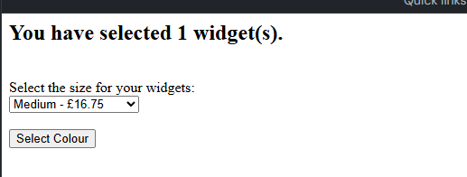

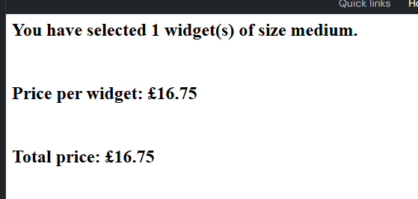

## **Exercise 4**

Draw a design for the revised shop. Ensure you include all the detail – Client & Server Pages, Forms and any controls that are contained within them.

Form Details:

Shop.HTML (client side.)

Purpose: The user selects the quantity of widgets they wish to purchase

Form Action: size.php

Form Method: POST

Controls:

Dropdown is select, which selects the quantity.

Options 1,2,3,4,5. (Each option is widget number.)

Submit button which proceeds to next step.

**Form Structure:**

<form action="size.php" method="post">

<label for="selqty">Select the qty of widgets you require:</label>

<select name="selqty" id="selqty">

<option value="1">1</option>

<option value="2">2</option>

<option value="3">3</option>

<option value="4">4</option>

<option value="5">5</option>

</select>

<input type="submit" value="Select Size"/>

</form>

selectcolour.php (Client-Side.)

Purpose: The user selects the widget colour they want to buy. The prices and size are already selected and displayed.

Form Action: confirmation.php.

Form Method: POST

Controls: Dropdown select for the colour.

Hidden input fields to pass the selected quantity and size to confirmation.php

Submit button to finalize the order.

**Form Structure:**

<form action="confirmation.php" method="post">

<label for="selcolour">Select the colour:</label>

<select name="selcolour" id="selcolour">

<option value="white">White</option>

<option value="red">Red</option>

<option value="yellow">Yellow</option>

<option value="green">Green</option>

<option value="blue">Blue</option>

</select>

<input type="hidden" name="selqty" value="[selected qty from shop.html]"/>

<input type="hidden" name="selsize" value="[selected size from size.php]"/>

<input type="submit" value="Confirm Order"/>

</form>

confirmation.php (Client Side)

Purpose: This page displays a summary of the users selections and calculates the total cost.

Server-Side: The total price is based on the selected size and quantity using a PHP switch statement.

Display: The quantity size and colour are displayed in the form of an order summary.

The total price is calculated and shown.

Page structure: Displays order details and displays price per widget and total price.

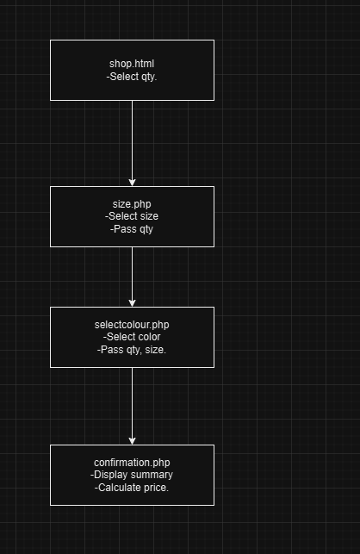

Conclusion:

This outline for the design gives a full view of the shopping process, which goes through the quantity selection, size and colour selection, which takes you to a confirmation page with a total cost calculation.